**Lab – 27**

**Student Name: Navneet P**

**Student ID: AF0411619**

***Topic: Pandas Pivot Table***

**Pivot table in Pandas:**

A **pivot table** in **Pandas** is a powerful tool for data summarization and transformation, used to group and aggregate data based on one or more columns. It's particularly useful for reshaping data for easier analysis, especially when dealing with large datasets.

pd.pivot_table(data, values=None, index=None, columns=None, aggfunc='mean', fill_value=None, margins=False, margins_name='All', dropna=True)

**Dataset used:** salesdata.csv

**Preview:**

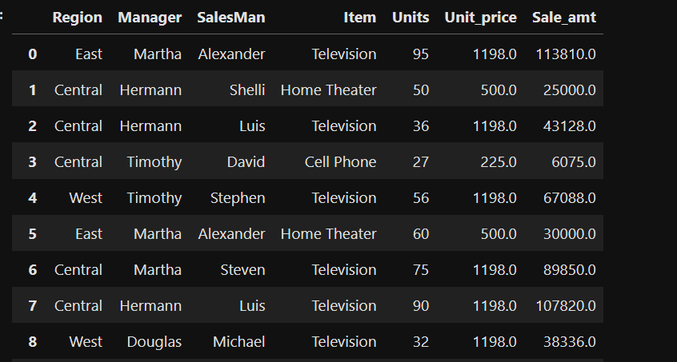

Question 1: Region-wise, Manager-wise and Salesman wise - To Find Total Sales Amount.

Solution:

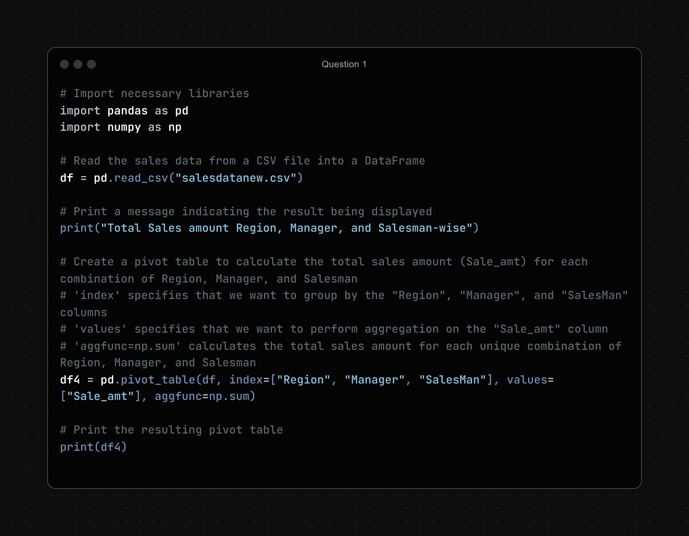

Output:

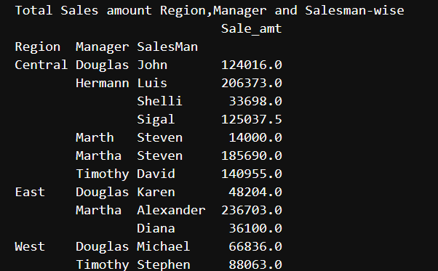

Question 2: Item-Wise - To find total Units

Solution: 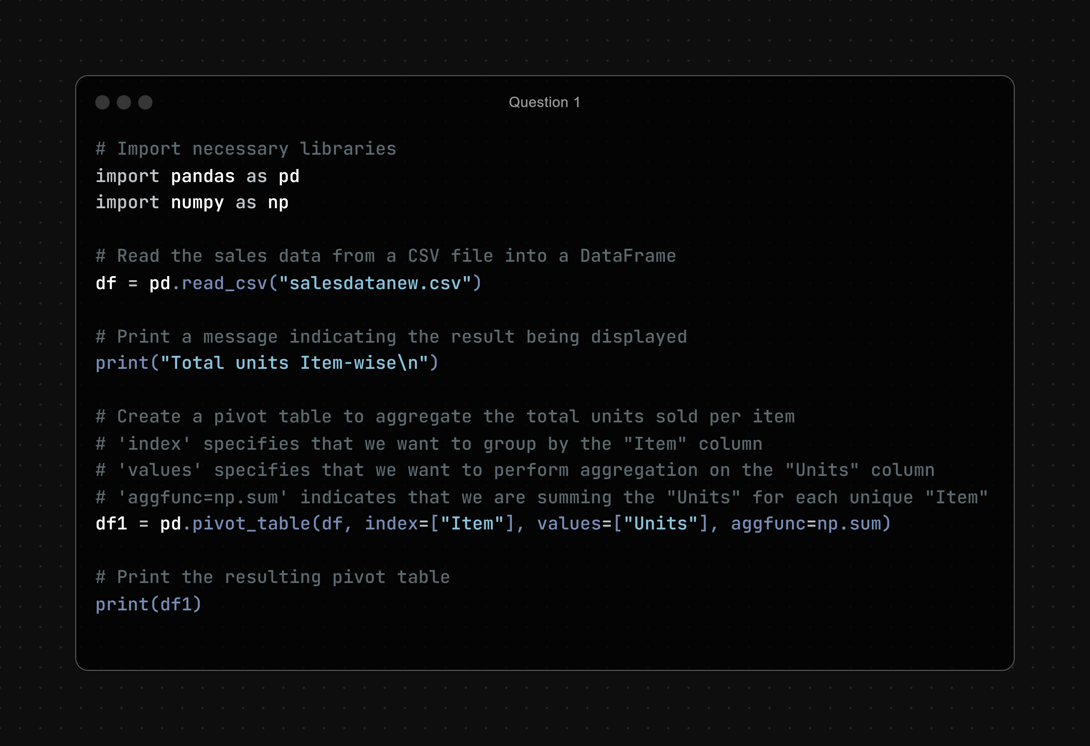

Output:

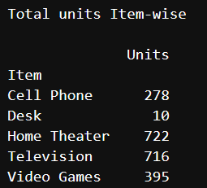

Question 3: Region-Wise, Item Wise - To find Sales Amt

Solution:

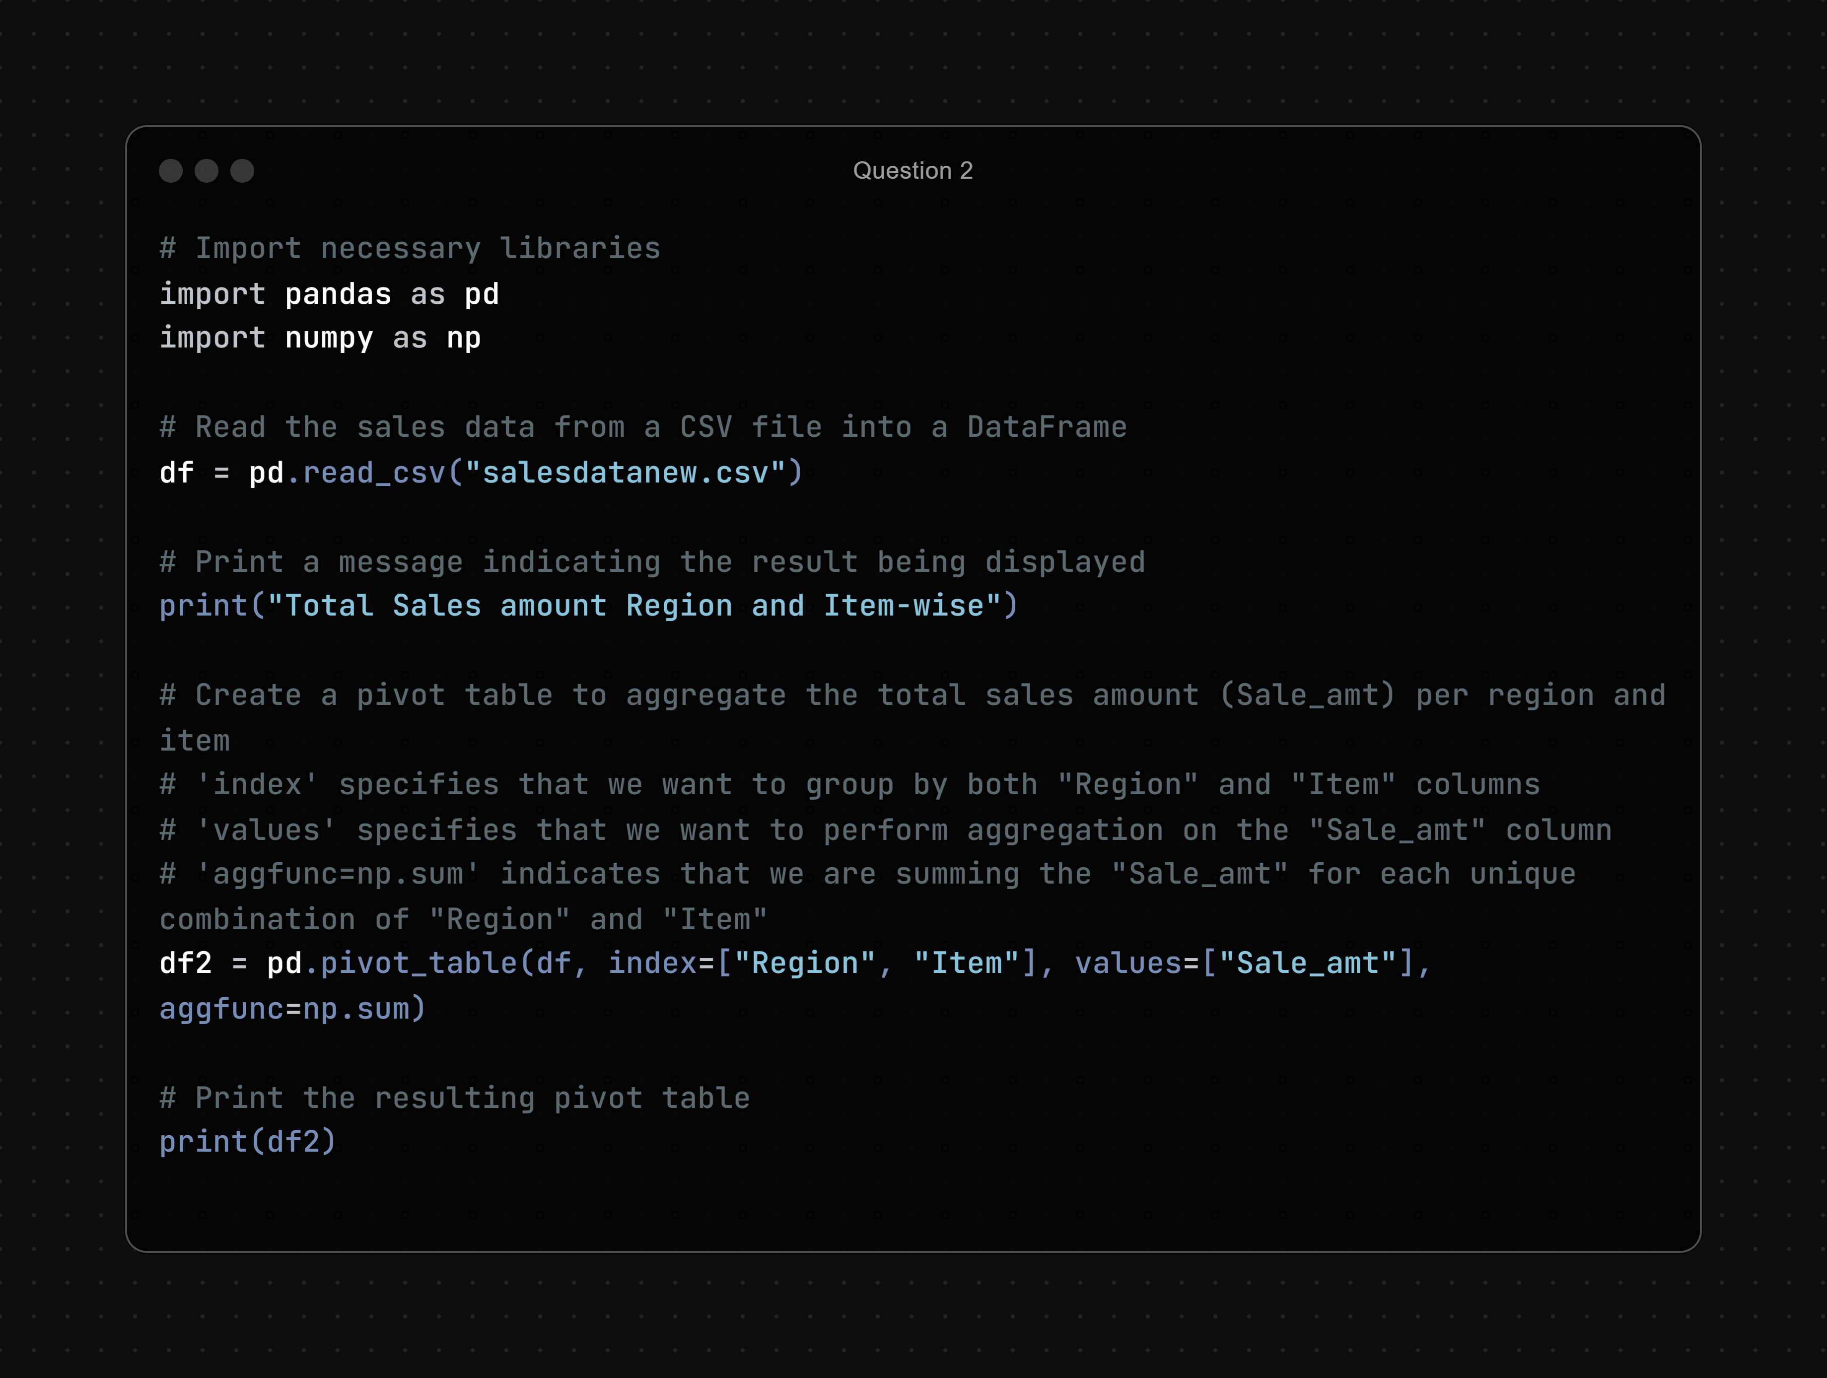

Output:

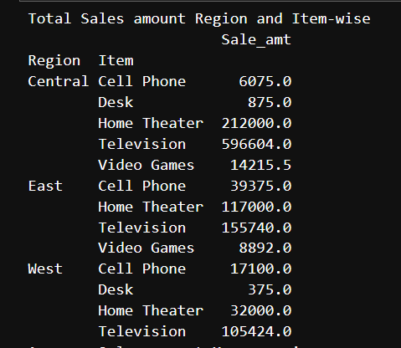

Question 4: Manager-Wise - To Find Mean Sale Amt

Solution:

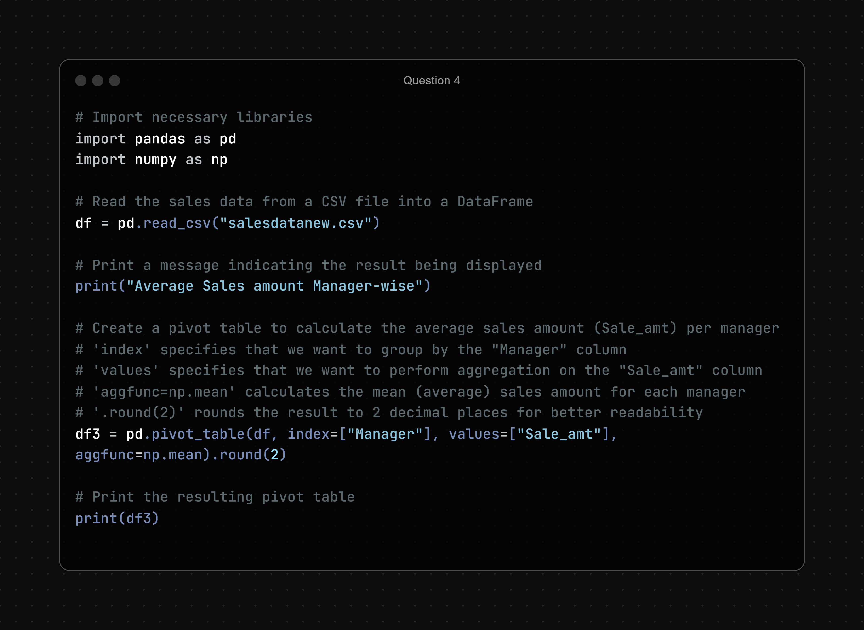

Output:

